**UI/UX LAB RECORD**



2022-2023

*submitted by*

FANINDRA SAINI

211B116

B4

*Submitted to:*

Dr. Dinesh Kumar Verma

**Department of Computer Science & Engineering**

**JAYPEE UNIVERSITY OF ENGINEERING & TECHNOLOGY,**

**AB ROAD, RAGHOGARH, DT. GUNA-473226 MP, INDIA**

Lab Exercise 1





Lab Exercise 2

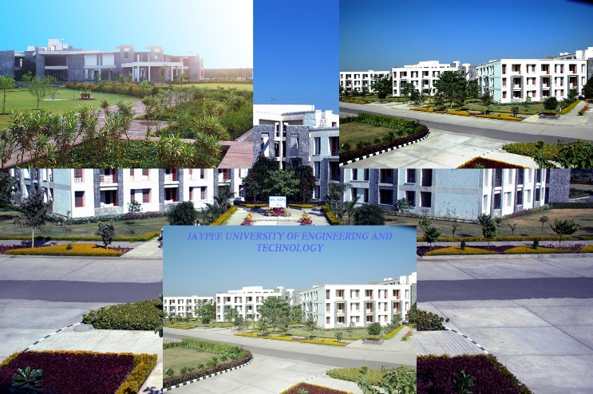 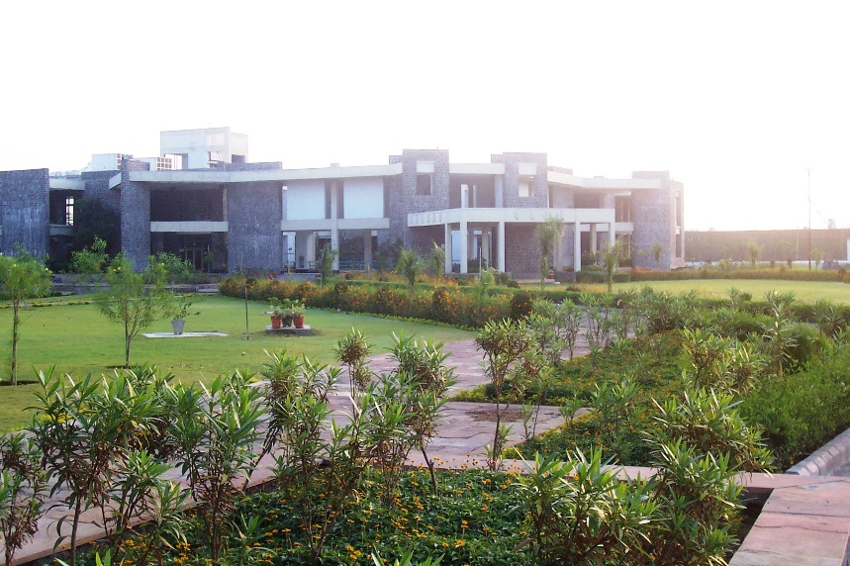

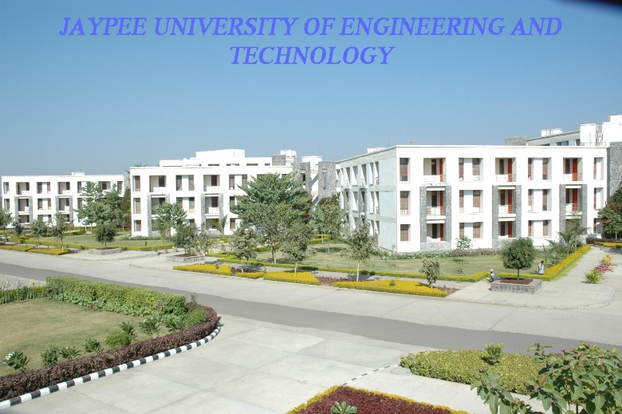 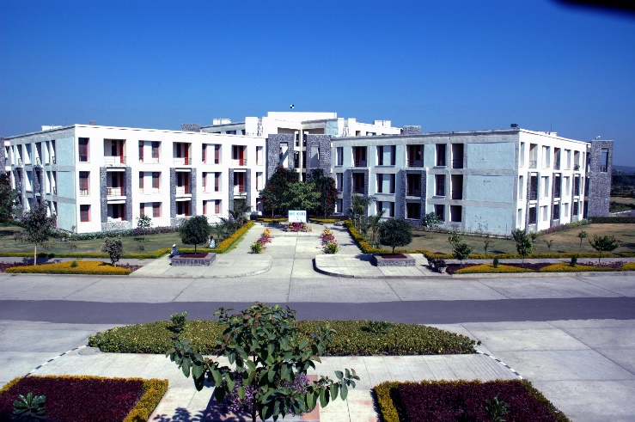

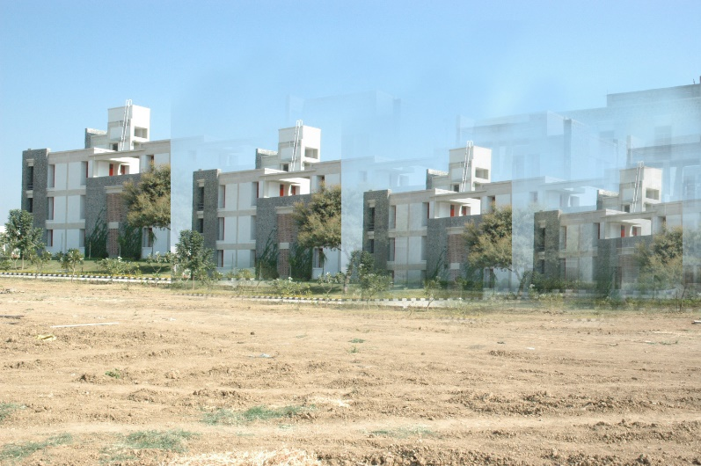 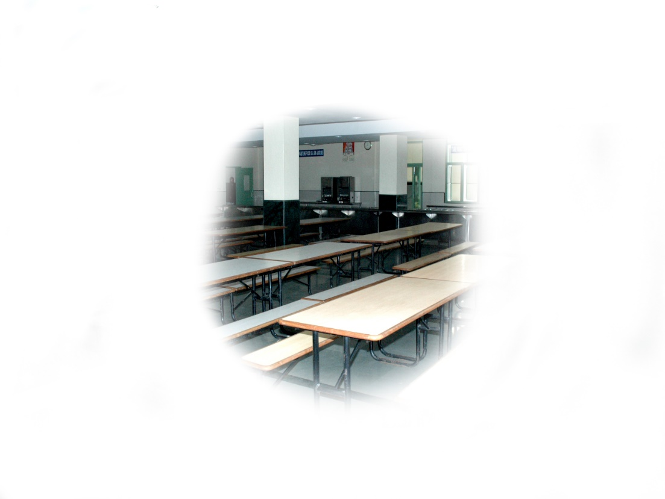

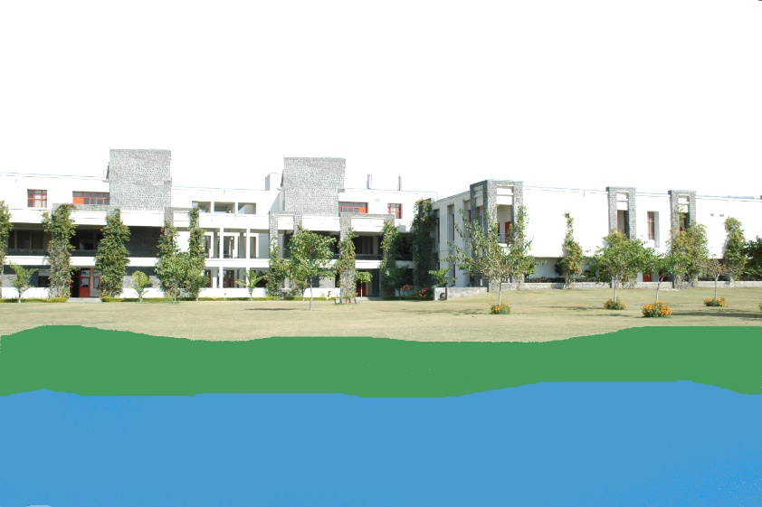 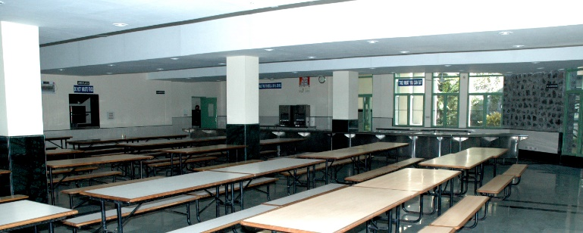

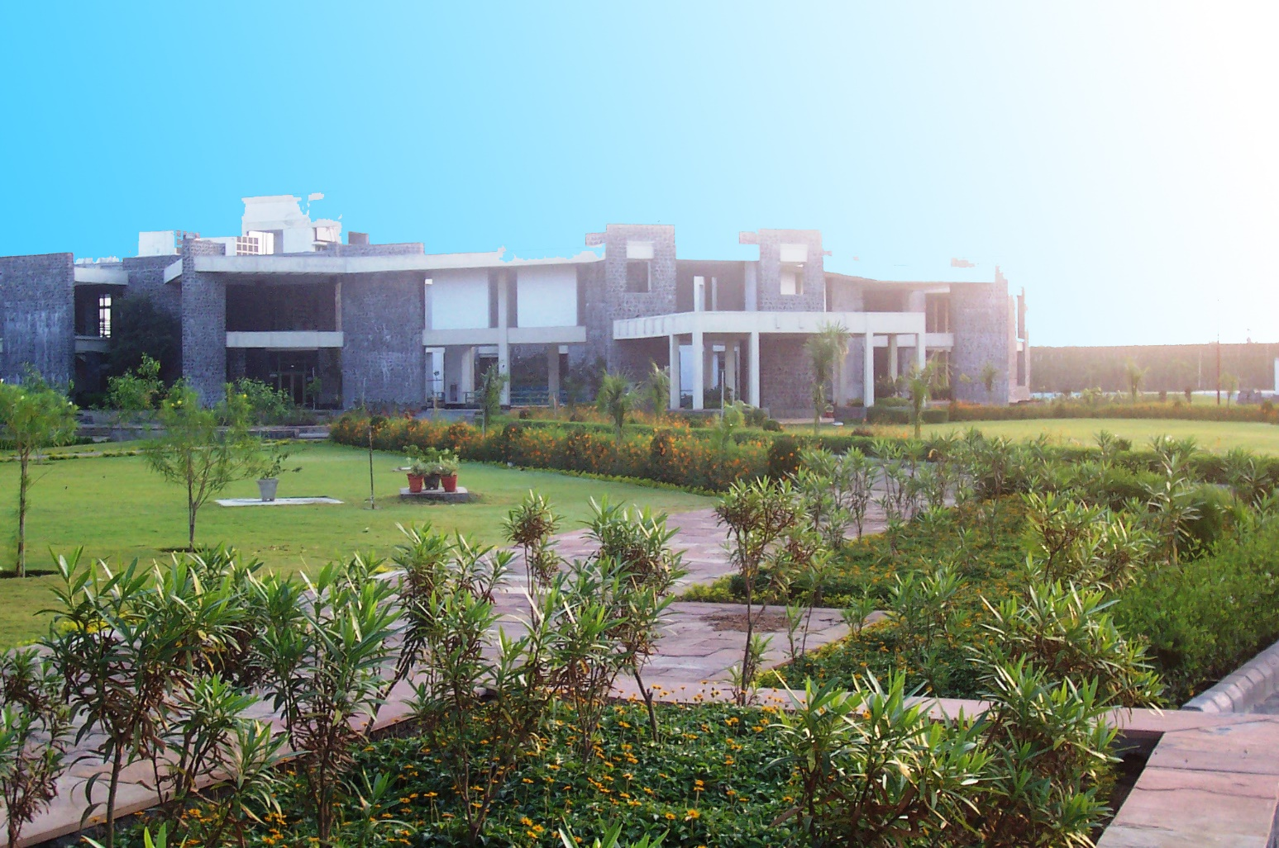

Lab Exercise 3

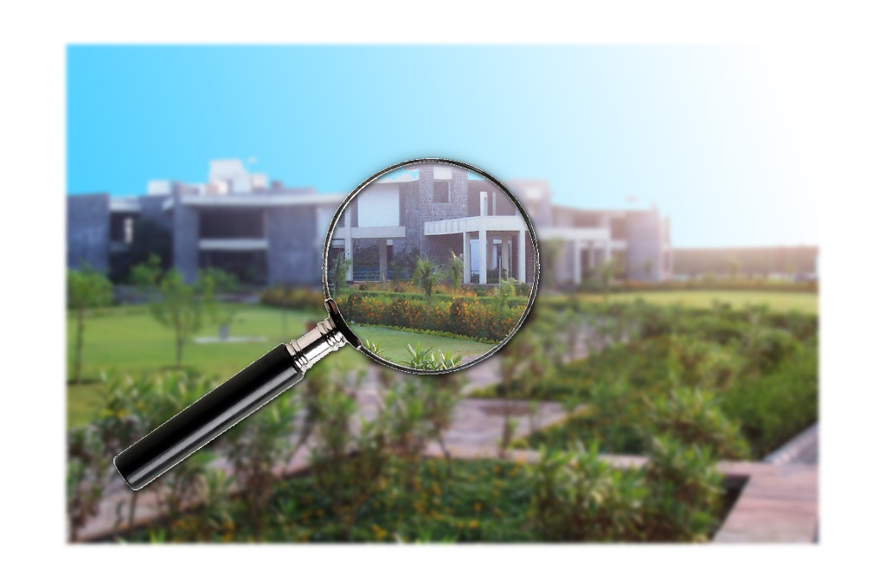

 

Lab Exercise 4

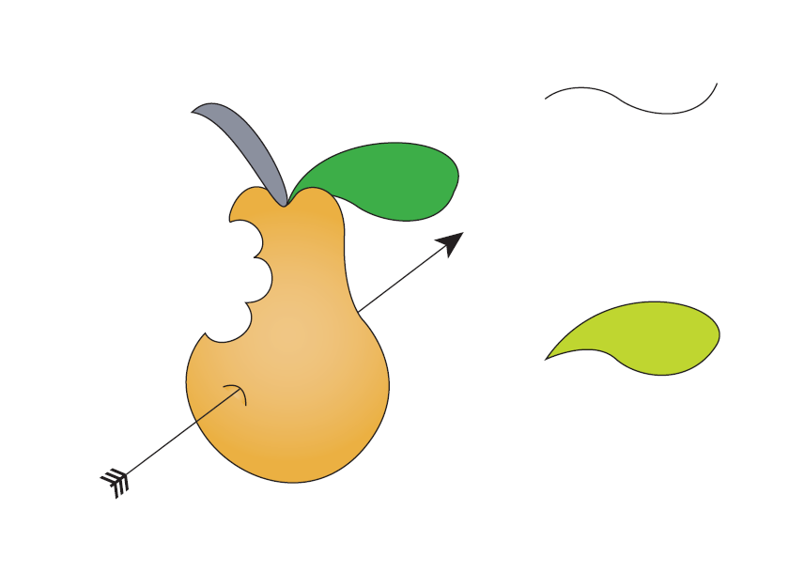

Lab Exercise 5

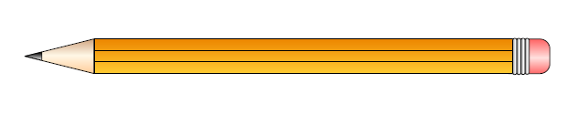

Lab Exercise 6

